Product distribution

Intro

A distribution that is constructed by product of random variables.

PDF

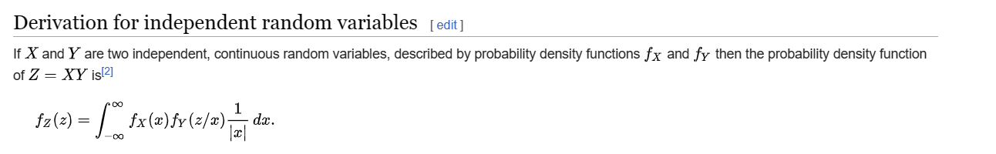

Proof:

Method 1:

First, we prove CDF of product distribution.

Lastly, we differentiate CDF to get PDF.

For first part, see proof below.

For last part,

$$F_{Z}\left(z\right)$$

= $$integral\left(f_{X}\left(x\right)⋅integral\left(f_{Y}\left(y\right)dy,y=−inf,y=\frac{z}{x}\right) dx,x=0,x=\inf{}\right)$$

+ $$integral\left(f_{X}\left(x\right)⋅integral\left(f_{Y}\left(y\right)dy,y=\frac{z}{x},y=\inf{}\right) dx,x=−inf,x=0\right)$$

$$f_{Z}\left(z\right)$$

= $$\frac{d}{dz}F_{Z}\left(z\right)$$

= $$\frac{d}{dz}\left[integral\left(f_{X}\left(x\right)⋅integral\left(f_{Y}\left(y\right)dy,y=−inf,y=\frac{z}{x}\right) dx,x=0,x=\inf{}\right)\right]$$

+ $$\frac{d}{dz}\left[integral\left(f_{X}\left(x\right)⋅integral\left(f_{Y}\left(y\right)dy,y=\frac{z}{x},y=\inf{}\right) dx,x=−inf,x=0\right)\right]$$

= $$integral\left(f_{X}\left(x\right)⋅\frac{d}{dz}\left[integral\left(f_{Y}\left(y\right)dy,y=−inf,y=\frac{z}{x}\right) \right]dx,x=0,x=\inf{}\right)$$

+ $$integral\left(f_{X}\left(x\right)⋅\frac{d}{dz}\left[integral\left(f_{Y}\left(y\right)dy,y=\frac{z}{x},y=\inf{}\right) \right]dx,x=−inf,x=0\right)$$

= $$integral\left(f_{X}\left(x\right)⋅\frac{f_{Y}\left(\frac{z}{x}\right)−0}{x}dx,x=0,x=\inf{}\right)$$

+ $$integral\left(f_{X}\left(x\right)⋅\frac{0−f_{Y}\left(\frac{z}{x}\right)}{x}dx,x=−inf,x=0\right)$$

= $$integral\left(f_{X}\left(x\right)⋅\frac{f_{Y}\left(\frac{z}{x}\right)}{\left|x\right|}dx,x=0,x=\inf{}\right)$$

+ $$integral\left(f_{X}\left(x\right)⋅\frac{f_{Y}\left(\frac{z}{x}\right)}{\left|x\right|}dx,x=−inf,x=0\right)$$

= $$integral\left(f_{X}\left(x\right)⋅\frac{f_{Y}\left(\frac{z}{x}\right)}{\left|x\right|}dx,x=−inf,x=\inf{}\right)$$

Method 2:

Again, first, we prove CDF of product distribution.

Lastly, we differentiate CDF to get PDF.

For first part, see proof below.

By definition of CDF

$$F_{Z}\left(z\right)$$

= $$\operatorname{Pr}\left(Z≤z\right)$$

= $$\operatorname{Pr}\left(XY≤z\right)$$

= $$integral\left(integral\left(f_{X}\left(x\right)⋅f_{Y}\left(y\right)⋅u\left(z−xy\right)dy,y=−inf,y=\inf{}\right),x=−inf,x=\inf{}\right)$$

where

$$u\left(x\right)$$ refers Heaviside step function.

For last part,

$$f_{Z}\left(z\right)$$

= $$\frac{d}{dz}F_{Z}\left(z\right)$$

= $$\frac{d}{dz}\left[integral\left(integral\left(f_{X}\left(x\right)⋅f_{Y}\left(y\right)⋅u\left(z−xy\right)dy,y=−inf,y=\inf{}\right),x=−inf,x=\inf{}\right)\right]$$

= $$integral\left(integral\left(f_{X}\left(x\right)⋅f_{Y}\left(y\right)⋅DiracDelta\left(z−xy\right)dy,y=−inf,y=\inf{}\right),x=−inf,x=\inf{}\right)$$

= $$integral\left(f_{X}\left(x\right)⋅\frac{f_{Y}\left(\frac{z}{x}\right)}{\left|x\right|},x=−inf,x=\inf{}\right)$$

where

DiracDelta refers Dirac Delta function.

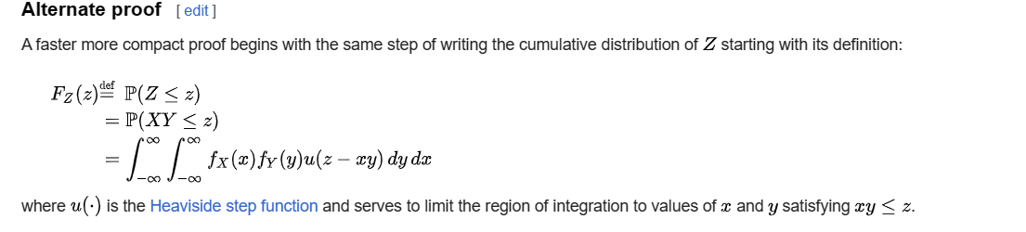

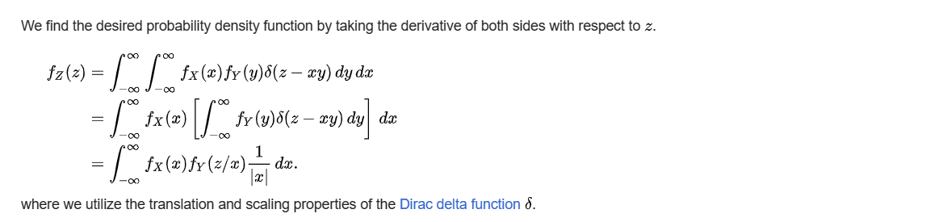

CDF





Proof:

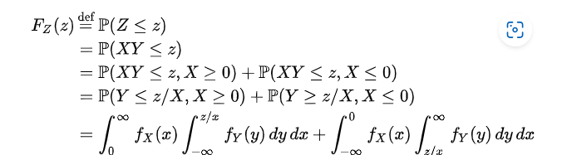

Expected Value

$$E\left[Z\right]$$

= $$E\left[XY\right]$$

$$E\left[X\right]⋅E\left[Y\right]$$

Proof:

One can prove it by law of total expectation.

$$E\left[Z\right]$$

= $$E\left[XY\right]$$

(by definition)

= $$E\left[E\left[XY\left|Y\right|\right]\right]$$

(by law of total expectation)

= $$E\left[Y⋅E\left[X\left|Y\right|\right]\right]$$

(since Y is independent to random variable X given by assumption)

= $$E\left[Y\right]⋅E\left[E\left[X\left|Y\right|\right]\right]$$

(since Y is a constant for random variable X given by assumption)

= $$E\left[Y\right]⋅E\left[X\left|Y\right|\right]$$

(since $$E\left[X\left|Y\right|\right]$$ is always a constant by axiom of expected value)

= $$E\left[Y\right]⋅E\left[X\right]$$

(since Y is independent to random variable X given by assumption)

= $$E\left[X\right]⋅E\left[Y\right]$$

(by mutation of multiplication)

Variance

Generalization



Suppose:

$$X_{1},…,X_{n}$$ be independent random variables.

And

$$Z=X_{1}…X_{n}$$

Then

$$Var\left(Z\right)$$

= $$Var\left(X_{1}…X_{n}\right)$$

= $$product\left(std{\left(X_{i}\right)}^{2}+E{\left[X_{i}\right]}^{2},i=1,i=n\right)$$



$$product\left(E{\left[X_{i}\right]}^{2},i=1,i=n\right)$$

Proof:

Proof by induction

Let $$S\left(n\right)$$: $$Var\left(X_{1}…X_{n}\right)$$

= $$product\left(std{\left(X_{i}\right)}^{2}+E{\left[X_{i}\right]}^{2},i=1,i=n\right)$$- $$product\left(E{\left[X_{i}\right]}^{2},i=1,i=n\right)$$

Base step:

$$S\left(1\right)$$ is true. Since

$$Var\left(X_{1}\right)$$ = $$Var\left[X_{1}\right]+E{\left[X_{1}\right]}^{2}−E{\left[X_{1}\right]}^{2}$$

= $$product\left(std{\left(X_{i}\right)}^{2}+E{\left[X_{i}\right]}^{2},i=1,i=1\right)$$- $$product\left(E{\left[X_{i}\right]}^{2},i=1,i=1\right)$$

$$S\left(2\right)$$ is also true. See the following proof.

By property of variance, we have that

$$Var\left(X_{1}X_{2}\right)$$

= $$E\left[{\left(X_{1}X_{2}\right)}^{2}\right]−E{\left[X_{1}X_{2}\right]}^{2}$$

= $$E\left[X_{1}^{2}X_{2}^{2}\right]−E{\left[X_{1}X_{2}\right]}^{2}$$

= $$E\left[X_{1}^{2}\right]E\left[X_{2}^{2}\right]−E{\left[X_{1}\right]}^{2}E{\left[X_{2}\right]}^{2}$$

(since $$X_{1},X_{2}$$ is independent)

= $$E\left[X_{1}^{2}\right]E\left[X_{2}^{2}\right]−E\left[X_{1}^{2}\right]E{\left[X_{2}\right]}^{2}−E{\left[X_{1}\right]}^{2}E\left[X_{2}^{2}\right]+E{\left[X_{1}\right]}^{2}E{\left[X_{2}\right]}^{2}$$

+ $$E\left[X_{1}^{2}\right]E\left[X_{2}^{2}\right]+E{\left[X_{1}\right]}^{2}E\left[X_{2}^{2}\right]−2E{\left[X_{1}\right]}^{2}E{\left[X_{2}\right]}^{2}$$

(adding and subtracting some terms)

= $$E\left[X_{1}^{2}\right]E\left[X_{2}^{2}\right]−E{\left[X_{1}\right]}^{2}E{\left[X_{2}\right]}^{2}$$ + $$E\left[X_{1}^{2}\right]E{\left[X_{2}\right]}^{2}−E\left[X_{1}^{2}\right]E{\left[X_{2}\right]}^{2}$$

+ $$E{\left[X_{1}\right]}^{2}E\left[X_{2}^{2}\right]−E{\left[X_{1}\right]}^{2}E\left[X_{2}^{2}\right]+E{\left[X_{1}\right]}^{2}E{\left[X_{2}\right]}^{2}−E{\left[X_{1}\right]}^{2}E{\left[X_{2}\right]}^{2}$$

= $$\left(E\left[X_{1}^{2}\right]−E{\left[X_{1}\right]}^{2}\right)\left(E\left[X_{2}^{2}\right]−E{\left[X_{2}\right]}^{2}\right)+E\left[X_{1}^{2}\right]E{\left[X_{2}\right]}^{2}+E{\left[X_{1}\right]}^{2}E{\left[X_{2}\right]}^{2}−2E{\left[X_{1}\right]}^{2}E{\left[X_{2}\right]}^{2}$$

=

$$\left(E\left[X_{1}^{2}\right]−E{\left[X_{1}\right]}^{2}\right)\left(E\left[X_{2}^{2}\right]−E{\left[X_{2}\right]}^{2}\right)+E\left[X_{1}^{2}\right]E{\left[X_{2}\right]}^{2}+E{\left[X_{1}\right]}^{2}E\left[X_{2}^{2}\right]+E{\left[X_{1}\right]}^{2}E{\left[X_{2}\right]}^{2}−E{\left[X_{1}\right]}^{2}E{\left[X_{2}\right]}^{2}−E{\left[X_{1}\right]}^{2}E{\left[X_{2}\right]}^{2}$$

=

$$Var\left(X_{1}\right)Var\left(X_{2}\right)+E\left[X_{1}^{2}\right]E{\left[X_{2}\right]}^{2}+E{\left[X_{1}\right]}^{2}E\left[X_{2}^{2}\right]+E{\left[X_{1}\right]}^{2}E{\left[X_{2}\right]}^{2}−E{\left[X_{1}\right]}^{2}E{\left[X_{2}\right]}^{2}−E{\left[X_{1}\right]}^{2}E{\left[X_{2}\right]}^{2}$$

(by property of variance)

=

$$Var\left(X_{1}\right)Var\left(X_{2}\right)+E\left[X_{1}^{2}\right]E{\left[X_{2}\right]}^{2}−E{\left[X_{1}\right]}^{2}E{\left[X_{2}\right]}^{2}+E{\left[X_{1}\right]}^{2}E\left[X_{2}^{2}\right]+E{\left[X_{1}\right]}^{2}E{\left[X_{2}\right]}^{2}−E{\left[X_{1}\right]}^{2}E{\left[X_{2}\right]}^{2}$$ = $$Var\left(X_{1}\right)Var\left(X_{2}\right)+\left(E\left[X_{1}^{2}\right]−E{\left[X_{1}\right]}^{2}\right)E{\left[X_{2}\right]}^{2}+\left(E\left[X_{2}^{2}\right]−E{\left[X_{2}\right]}^{2}\right)E{\left[X_{1}\right]}^{2}$$

= $$Var\left(X_{1}\right)Var\left(X_{2}\right)+Var\left(X_{1}\right)E{\left[X_{2}\right]}^{2}+Var\left(X_{2}\right)E{\left[X_{1}\right]}^{2}$$

(by property of variance)

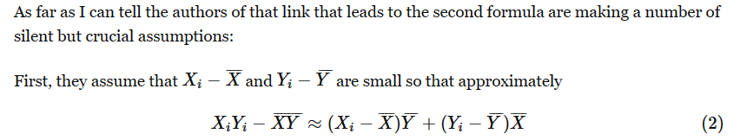

$$X_{1}$$-> $$E\left[X_{1}\right]$$

$$X_{2}$$-> $$E\left[X_{2}\right]$$

$$X_{1}X_{2}$$-> $$E\left[X_{1}X_{2}\right]$$

=>

$$X_{1}−E\left[X_{1}\right]$$-> 0

$$X_{2}−E\left[X_{2}\right]$$-> 0

$$X_{1}X_{2}−E\left[X_{1}X_{2}\right]$$-> 0

=>

$$\left(X_{1}−E\left[X_{1}\right]\right)⋅\left(X_{2}−E\left[X_{2}\right]\right)$$-> 0

$$X_{1}X_{2}−E\left[X_{1}X_{2}\right]$$-> 0

=>

$$X_{1}X_{2}−E\left[X_{1}X_{2}\right]$$-> $$\left(X_{1}−E\left[X_{1}\right]\right)\left(X_{2}−E\left[X_{2}\right]\right)$$

On the other hand,

$$X_{1}−E\left[X_{1}\right]$$

-> 0

=> $$E\left[X_{1}−E\left[X_{1}\right]\right]$$

-> 0

Doing so for $$X_{2}$$.

Futhermore,

$$Cov\left(X_{1},X_{2}\right)$$ = $$E\left[\left(X_{1}−E\left[X_{1}\right]\right)\left(X_{2}−E\left[X_{2}\right]\right)\right]$$-> $$E\left[0\right]$$ = 0

And thus,

$$Var\left[X_{1}X_{2}\right]$$

= $$E\left[{\left(X_{1}X_{2}−E\left[X_{1}X_{2}\right]\right)}^{2}\right]$$

= $$E\left[X_{1}^{2}X_{2}^{2}−2X_{1}X_{2}E\left[X_{1}\right]E\left[X_{2}\right]+E{\left[X_{1}X_{2}\right]}^{2}\right]$$

= $$E\left[X_{1}^{2}X_{2}^{2}\right]−E\left[2X_{1}X_{2}E\left[X_{1}\right]E\left[X_{2}\right]\right]+E\left[E{\left[X_{1}X_{2}\right]}^{2}\right]$$

= $$E{\left[X_{1}\right]}^{2}E{\left[X_{2}\right]}^{2}−2E\left[X_{1}\right]E\left[X_{2}\right]E\left[X_{1}\right]E\left[X_{2}\right]+E{\left[X_{1}\right]}^{2}E{\left[X_{2}\right]}^{2}$$

= 0

-> 0

Hence,

$$E\left[4X_{1}X_{2}E\left[X_{1}\right]E\left[X_{2}\right]\right]$$

= 0

-> 0

Adding the above two approximations together. We have that

$$Var\left(X_{1}X_{2}\right)$$ + $$E\left[4X_{1}X_{2}E\left[X_{1}\right]E\left[X_{2}\right]\right]$$

-> 0 + 0 = 0

=>

$$E\left[X_{1}^{2}X_{2}^{2}+2X_{1}X_{2}E\left[X_{1}\right]E\left[X_{2}\right]+E{\left[X_{1}X_{2}\right]}^{2}\right]$$

-> 0

Combing the previous two claims, we can get that

=>

$$E\left[X_{1}^{2}X_{2}^{2}+2X_{1}X_{2}E\left[X_{1}\right]E\left[X_{2}\right]+E{\left[X_{1}X_{2}\right]}^{2}\right]$$

= $$E\left[X_{1}^{2}X_{2}^{2}\right]+2E\left[X_{1}X_{2}E\left[X_{1}\right]E\left[X_{2}\right]\right]+E\left[E{\left[X_{1}X_{2}\right]}^{2}\right]$$

= $$E\left[X_{1}^{2}\right]E\left[X_{2}^{2}\right]+2E\left[X_{1}\right]E\left[X_{2}\right]E\left[E\left[X_{1}\right]\right]E\left[E\left[X_{2}\right]\right]+E{\left[X_{1}X_{2}\right]}^{2}$$

= $$E{\left[X_{1}\right]}^{2}E{\left[X_{2}\right]}^{2}+2E\left[X_{1}\right]E\left[X_{2}\right]E\left[X_{1}\right]E\left[X_{2}\right]+E{\left[X_{1}X_{2}\right]}^{2}$$

= $$Var\left(X_{1}\right)E{\left[X_{2}\right]}^{2}+E{\left[X_{1}\right]}^{2}Var\left(X_{2}\right)+2⋅Cov\left(X_{1},X_{2}\right)E\left[X_{1}\right]E\left[X_{2}\right]$$

-> $$Var\left(X_{1}X_{2}\right)$$

-> 0

By previous claim,

$$Cov\left(X_{1},X_{2}\right)$$-> 0

And thus,

$$Var\left(X_{1}X_{2}\right)$$

-> $$Var\left(X_{1}\right)E{\left[X_{2}\right]}^{2}+E{\left[X_{1}\right]}^{2}Var\left(X_{2}\right)$$

-> 0

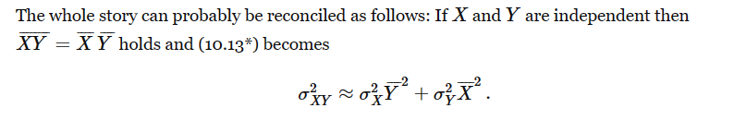

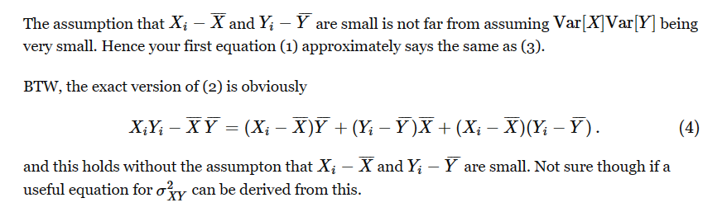

From the reply in the following website.

[Variance of product of two random variables ($f(X, Y) = XY$) - Mathematics Stack Exchange](https://math.stackexchange.com/questions/4271183/variance-of-product-of-two-random-variables-fx-y-xy)

Hence, we have completed the proof of $$S\left(2\right)$$

Inductive step:

By inductive hypothesis, it is true for $$S\left(m\right)$$ for any $$m≥2$$ and $$m$$ is an integer.

We have to prove that it is also true for $$S\left(m+1\right)$$.

Explain it with details.

$$S\left(m\right)$$:

$$Var\left(X_{1}…X_{m}\right)$$

= $$product\left(std{\left(X_{i}\right)}^{2}+E{\left[X_{i}\right]}^{2},i=1,i=m\right)$$- $$product\left(E{\left[X_{i}\right]}^{2},i=1,i=m\right)$$

While we have to prove

$$S\left(m+1\right)$$:

$$Var\left(X_{1}…X_{m}X_{m+1}\right)$$

= $$product\left(std{\left(X_{i}\right)}^{2}+E{\left[X_{i}\right]}^{2},i=1,i=m+1\right)$$

- $$product\left(E{\left[X_{i}\right]}^{2},i=1,i=m+1\right)$$

$$Var\left(X_{1}…X_{m}X_{m+1}\right)$$

= $$Var\left(\left(X_{1}…X_{m}\right)X_{m+1}\right)$$

= $$\left[std{\left(X_{1}…X_{m}\right)}^{2}+E{\left[X_{1}…X_{m}\right]}^{2}\right]\left[std{\left(X_{m+1}\right)}^{2}+E{\left[X_{m+1}\right]}^{2}\right]$$

$$\left[E{\left[X_{1}…X_{m}\right]}^{2}E{\left[X_{m+1}\right]}^{2}\right]$$

= $$std{\left(X_{1}…X_{m}\right)}^{2}\left[std{\left(X_{m+1}\right)}^{2}+E{\left[X_{m+1}\right]}^{2}\right]$$

+ $$E{\left[X_{1}…X_{m}\right]}^{2}\left[std{\left(X_{m+1}\right)}^{2}+E{\left[X_{m+1}\right]}^{2}\right]$$

$$\left[E{\left[X_{1}…X_{m}\right]}^{2}E{\left[X_{m+1}\right]}^{2}\right]$$

= $$std{\left(X_{1}…X_{m}\right)}^{2}\left[std{\left(X_{m+1}\right)}^{2}+E{\left[X_{m+1}\right]}^{2}\right]$$

+ $$E{\left[X_{1}…X_{m}\right]}^{2}std{\left(X_{m+1}\right)}^{2}$$

+ $$E{\left[X_{1}…X_{m}\right]}^{2}E{\left[X_{m+1}\right]}^{2}$$

$$E{\left[X_{1}…X_{m}\right]}^{2}E{\left[X_{m+1}\right]}^{2}$$

= $$std{\left(X_{1}…X_{m}\right)}^{2}\left[std{\left(X_{m+1}\right)}^{2}+E{\left[X_{m+1}\right]}^{2}\right]$$

+ $$E{\left[X_{1}…X_{m}\right]}^{2}std{\left(X_{m+1}\right)}^{2}$$

= $$product\left(std{\left(X_{i}\right)}^{2}+E{\left[X_{i}\right]}^{2},i=1,i=m+1\right)$$

$$product\left(E{\left[X_{i}\right]}^{2},i=1,i=m+1\right)$$

+ $$E{\left[X_{1}…X_{m}\right]}^{2}std{\left(X_{m+1}\right)}^{2}$$

= $$product\left(std{\left(X_{i}\right)}^{2}+E{\left[X_{i}\right]}^{2},i=1,i=m+1\right)$$

$$product\left(E{\left[X_{i}\right]}^{2},i=1,i=m+1\right)$$

+ $$E{\left[X_{1}…X_{m}\right]}^{2}\left[E\left[X_{m+1}^{2}\right]−E{\left[X_{m+1}\right]}^{2}\right]$$

= $$product\left(std{\left(X_{i}\right)}^{2}+E{\left[X_{i}\right]}^{2},i=1,i=m+1\right)$$

$$product\left(E{\left[X_{i}\right]}^{2},i=1,i=m+1\right)$$

+ $$E{\left[X_{1}…X_{m}\right]}^{2}$$ $$E\left[X_{m+1}^{2}\right]$$

- $$E{\left[X_{1}…X_{m}\right]}^{2}$$ $$E{\left[X_{m+1}\right]}^{2}$$

= $$product\left(std{\left(X_{i}\right)}^{2}+E{\left[X_{i}\right]}^{2},i=1,i=m+1\right)$$

$$product\left(E{\left[X_{i}\right]}^{2},i=1,i=m+1\right)$$

+

- $${\left[E\left[X_{1}\right]⋅…⋅E\left[X_{m+1}\right]\right]}^{2}$$

By inductive hypothesis, we have that

$$std\left(X_{1}…X_{m}\right)$$

= $$product\left(std{\left(X_{i}\right)}^{2}+E{\left[X_{i}\right]}^{2},i=1,i=m\right)$$

- $$product\left(E{\left[X_{i}\right]}^{2},i=1,i=m\right)$$

$$E{\left[X_{1}…X_{m}\right]}^{2}E{\left[X_{m+1}\right]}^{2}$$

Imply this formula to above formula.

Two independent random variables

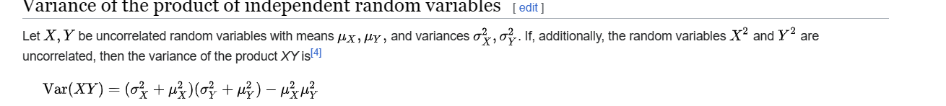

Diagram

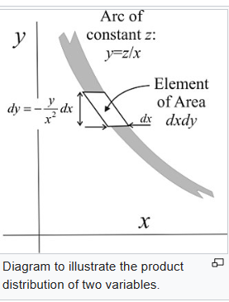

Ref

[Distribution of the product of two random variables - Wikipedia](https://en.wikipedia.org/wiki/Distribution_of_the_product_of_two_random_variables)